AZURE-BASED SITUATION AWARE CRICKET ANALYTICS
A Project Report Submitted in the partial fulfillment of the
requirements for the award of the degree of

BACHELOR OF TECHNOLOGY
In
DEPARTMENT OF COMPUTER SCIENCE ENGINEERING

By
T. Chetan Satvik (2320090026)
K. Vihaari (2320090027)
Ch. Nikith (2320090023)

Under the Esteemed Guidance of

LECTURE NAME PRATHUSHA BONAGANI



K L (Deemed to be) University

DEPARTMENT OF COMPUTER SCIENCE ENGINEERING


Declaration

The Project Report entitled “Azure-Based Situation Aware Cricket Analytics” is a record of Bonafide work of team members T. Chetan Satvik - 2320090026, K. Vihaari - 2320090027, Ch. Nikith - 2320090023, submitted in partial fulfilment for the award of B. Tech in Computer Engineering to K L University. The results embodied in this report have not been copied from any other departments/University/Institute.

T. Chetan Satvik (2320090026)
K. Vihaari (2320090027)
Ch. Nikith (2320090023)

K L (Deemed to be) University DEPARTMENT OF COMPUTER SCIENCE ENGINEERING


Certificate

This is to certify that the project-based report entitled “Azure-Based Situation Aware Cricket Analytics” is a Bonafide work carried out and submitted by T. Chetan Satvik - 2320090026, K. Vihaari - 2320090027, Ch. Nikith - 2320090023, in partial fulfilment of the requirements for the award of the degree of Bachelor of Technology in Computer Science Engineering, at K L (Deemed to be University), during the academic year 2025–2026.

Signature of the Supervisor

Signature of the HOD Signature of the External Examiner

ACKNOWLEDGEMENT
The success in this project would not have been possible but for the timely help and guidance rendered by many people. Our wish to express my sincere thanks to all those who has assisted us in one way or the other for the completion of my project.

Our greatest appreciation to my guide, Prathusha Bonagani, Department of Computer Science which cannot be expressed in words for his tremendous support, encouragement and guidance for this project.

We express our gratitude to Dr. N. Sirisha, Head of the Department for Computer Science Engineering for providing us with adequate facilities, ways and means by which we can complete this project-based Lab.

We thank all the members of teaching and non-teaching staff members, and who have assisted me directly or indirectly for successful completion of this project. Finally, we sincerely thank our parents, friends and classmates for their kind help and cooperation during my work.

T. Chetan Satvik (2320090026)
K. Vihaari (2320090027)
Ch. Nikith (2320090023)

TABLE OF CONTENTS

S.No | Contents | Page no
1 | Abstract | 6
2 | Introduction | 7
3 | Literature survey | 8
4 | Hardware and Software requirements | 12
5 | Implementation | 14
6 | Experimentation and Code | 17
7 | Results | 20
8 | Conclusion | 24
9 | References | 25

ABSTRACT

The rapid growth of data in modern sports has created a need for advanced analytical systems that can transform raw data into meaningful insights. Cricket, being a data-intensive sport, generates large volumes of ball-by-ball data that contain valuable information about player performance, match conditions, and game outcomes. However, traditional methods of analysis often rely on basic statistics and fail to capture the contextual aspects of performance.
This project presents a Cricket Analytics Web Application developed using Streamlit, aimed at providing an interactive and data-driven approach to analysing player performance. The system processes ball-by-ball cricket data to compute key performance metrics such as runs, strike rate, batting average, and dismissals. These metrics are further analysed under different match conditions, including phases of play (Powerplay, Middle overs, and Death overs) and bowler-specific scenarios.
The application provides a user-friendly interface where users can select players, bowlers, and match phases to dynamically compare performance. The system also includes graphical visualizations and an automated recommendation feature that identifies the better-performing player based on calculated metrics. Additionally, a ranking mechanism is implemented to identify top-performing players under selected conditions.
The project demonstrates how data analytics techniques can be effectively applied in sports to enhance decision-making. By combining data processing, visualization, and interactivity, the system provides a comprehensive solution for cricket analytics.

INTRODUCTION

Cricket has evolved into a highly data-driven sport where performance analysis plays a crucial role in strategy and decision-making. Every match generates detailed ball-by-ball data that contains valuable information about players, match conditions, and outcomes. However, traditional methods of analysis rely on basic statistics such as total runs, batting average, and strike rate, which do not fully capture the context of player performance.
Modern analytics focuses on extracting deeper insights from data by considering factors such as match phase, opponent, and game situation. This project aims to develop an interactive cricket analytics system that enables users to analyze player performance dynamically and make informed decisions.

1. Problem Description
Despite the availability of large volumes of cricket data, most analysis methods fail to utilize it effectively for decision-making. Traditional metrics provide only a generalized view of performance and do not consider contextual factors such as match phase (Powerplay, Middle overs, Death overs) or specific bowler interactions.
For example, a player may perform exceptionally well in death overs but poorly in powerplay, which cannot be clearly identified using basic statistics. Similarly, performance against specific bowlers is often overlooked.
The key problem addressed in this project is:
To develop a system that enables context-aware analysis of cricket data and provides meaningful insights for player comparison and decision-making.

2. Objectives
The main objectives of this project are:
- To develop a web-based cricket analytics application using Streamlit
- To analyze ball-by-ball cricket data efficiently
- To compute key performance metrics such as:
  - Runs
  - Strike Rate
  - Batting Average
- To enable player comparison based on:
  - Match phases (Powerplay, Middle, Death)
  - Bowler-specific performance
- To provide graphical visualization of player performance
- To implement a recommendation system to identify the better-performing player
- To identify top-performing players under selected conditions
The overall objective is to transform raw cricket data into meaningful insights that support data-driven decision-making.

LITERATURE SURVEY

The field of cricket analytics has undergone significant transformation with the advancement of data analytics, machine learning, and big data technologies. Traditionally, cricket analysis was limited to basic statistical measures, but modern approaches have introduced more sophisticated techniques to extract deeper insights from data. This section reviews different approaches used in cricket analytics and highlights their strengths, limitations, and relevance to the proposed system.

Traditional Cricket Analytics
1. Overview
Traditional cricket analytics primarily relies on basic statistical metrics such as batting average, strike rate, total runs scored, and number of wickets taken. These metrics have been widely used by analysts, commentators, and team management to evaluate player performance.
Batting average is calculated as the ratio of total runs scored to the number of dismissals, while strike rate represents the number of runs scored per 100 balls faced. These metrics provide a general understanding of a player’s performance over time.

2. Advantages
- Simple and easy to compute
- Widely accepted and understood
- Useful for overall performance evaluation
- Requires minimal computational resources

3. Limitations
Despite their simplicity, traditional methods have several limitations:
- Lack of contextual analysis (do not consider match situations)
- Inability to differentiate performance across phases of the game
- No consideration of opposition strength or specific bowlers
- Limited support for strategic decision-making

4. Relevance to the Project
The proposed system improves upon traditional methods by incorporating context-aware analysis, allowing performance evaluation based on match phase and bowler-specific conditions.

Machine Learning-Based Cricket Analytics
1. Overview
Machine learning techniques have been widely used in sports analytics to predict player performance, match outcomes, and team strategies. These models use historical data to identify patterns and relationships between variables.
Common machine learning approaches in cricket analytics include:
- Regression models for predicting runs or scores
- Classification models for predicting match outcomes
- Clustering techniques for player grouping

2. Advantages
- Ability to identify complex patterns in data
- Predictive capabilities
- Supports advanced decision-making
- Can handle large datasets

3. Limitations
- Requires large volumes of training data
- High computational complexity
- Difficult to interpret results
- Requires expertise in model development

4. Challenges
- Data preprocessing and cleaning
- Model selection and tuning
- Overfitting and accuracy issues
- Deployment in real-time systems

5. Relevance to the Project
Although machine learning provides advanced capabilities, this project focuses on simpler analytical methods such as filtering and aggregation. This approach ensures ease of implementation while still providing meaningful insights.

Big Data-Based Cricket Analytics
1. Overview
With the increase in data volume, big data technologies have been adopted to process and analyze cricket datasets efficiently. Ball-by-ball data generates a large amount of information, making traditional processing methods inefficient.
Technologies such as Apache Spark and Hadoop are commonly used to handle large datasets and perform distributed processing.
2. Advantages
- Efficient handling of large-scale datasets
- High scalability
- Faster data processing
- Enables detailed and granular analysis
3. Limitations
- Requires complex infrastructure
- High setup and maintenance cost
- Requires technical expertise
- Not always necessary for small-scale applications
4. Challenges
- Data integration from multiple sources
- Data cleaning and preprocessing
- Managing distributed systems
- Ensuring data consistency
5. Relevance to the Project
The dataset used in this project is structured and manageable, so full-scale big data infrastructure is not required. However, the concept of handling large datasets efficiently is incorporated in the design of the system.

4. Data Visualization in Sports Analytics
1. Overview
Data visualization plays a crucial role in analytics by transforming numerical data into graphical representations. Tools such as Power BI, Tableau, and Streamlit enable users to understand patterns and trends easily.
Visualization techniques include:
- Bar charts
- Line graphs
- Comparative dashboards

2. Advantages
- Easy interpretation of data
- Helps identify trends and patterns
- Enhances decision-making
- Improves user interaction

3. Limitations
- Limited analytical capability without proper data processing
- Requires proper design for clarity
- May oversimplify complex data

4. Relevance to the Project
This project heavily relies on visualization to present results. The use of Streamlit charts and comparison graphs helps users understand player performance effectively.

5. Summary of Literature Review
The literature review highlights the evolution of cricket analytics from traditional statistical methods to advanced data-driven approaches. While machine learning and big data techniques provide powerful tools for analysis, they often involve complexity and high resource requirements.
The proposed system adopts a balanced approach by combining:
- Traditional statistical metrics
- Context-aware data filtering
- Interactive visualization
This approach ensures that the system is:
- Simple and efficient
- Easy to implement
- Capable of providing meaningful insights

HARDWARE AND SOFTWARE REQUIREMENTS:

The development and execution of the Cricket Analytics Web Application require appropriate hardware and software components to ensure smooth performance and efficient data processing. The system is designed to be lightweight and does not require high-end infrastructure, making it accessible and easy to implement.

1. Hardware Requirements
The system can run on a standard laptop or desktop with moderate specifications. Since the application mainly performs data filtering, aggregation, and visualization, it does not require heavy computational power.
The minimum hardware requirements include:
- A laptop or desktop computer
- Processor: Intel i5 or equivalent
- RAM: Minimum 8 GB
- Storage: At least 10 GB of free space
- Display: Standard graphical display
For better performance, especially when handling larger datasets, a system with an Intel i7 processor, 16 GB RAM, and SSD storage is recommended.
These specifications ensure that the application runs smoothly without delays and provides quick response to user inputs.

2. Software Requirements
The system is developed using Python and its associated libraries, which provide powerful tools for data analysis and web application development.
The required software includes:
- Operating System: Windows, macOS, or Linux
- Programming Language: Python
The following libraries are used:
- Pandas: For data loading, cleaning, filtering, and aggregation
- Streamlit: For building the web-based user interface
- Matplotlib: For visualization
In addition, the following tools are used during development:
- Visual Studio Code or any Python IDE
- Terminal or command prompt for running the application
- pip for installing required libraries
A web browser is required to view and interact with the Streamlit application.

3. System Environment
The application is executed in a local development environment where the dataset is stored in CSV format. The data is processed using Python, and the output is displayed through a Streamlit web interface.
The workflow includes:
- Loading the dataset
- Processing and filtering data
- Calculating performance metrics
- Displaying results through charts and tables
This environment ensures simplicity, ease of development, and efficient execution of the system.

4. Summary
The proposed system is designed to be efficient and user-friendly, requiring only standard hardware and widely available software tools. The combination of Python, Pandas, and Streamlit ensures fast processing, easy development, and effective visualization.
Overall, the system provides a balance between performance and simplicity, making it suitable for real-world analytics applications.

IMPLEMENTATION
The implementation of the Cricket Analytics Web Application involves multiple steps including data preparation, processing, and development of the user interface. The system is designed to transform raw cricket data into meaningful insights through efficient computation and visualization.
1. Data Collection and Preparation
The first step in the implementation is collecting the dataset. The project uses a ball-by-ball cricket dataset containing detailed information about matches and deliveries.
The dataset consists of two main files:
- Deliveries dataset (ball-by-ball data)
- Matches dataset (match-level information)
These datasets are loaded using the Pandas library and merged based on a common key (match_id). Data cleaning is performed to handle missing values and ensure consistency.
A new feature called “phase” is created to classify overs into:
- Powerplay (Overs 1–6)
- Middle Overs (Overs 7–15)
- Death Overs (Overs 16–20)
This helps in performing situation-based analysis.
2. Data Processing and Computation
After preparing the dataset, the system performs data filtering and aggregation based on user inputs.
The filtering is done based on:
- Selected batsmen
- Selected bowler (optional)
- Selected match phase
Once the data is filtered, key performance metrics are calculated:
- Runs: Total runs scored
- Balls: Number of deliveries faced
- Strike Rate: (Runs / Balls) × 100
- Average: Runs / Dismissals
These calculations are performed dynamically, ensuring real-time updates when user inputs change.
3. User Interface Development
The user interface is developed using Streamlit, which provides an interactive and easy-to-use platform.
The interface includes:
- Dropdown menus for selecting players
- Options to select bowler and match phase
- Display of selected inputs
- Tables showing player comparison
The design focuses on simplicity and clarity, allowing users to perform analysis without technical knowledge.
4. Visualization and Output
The system presents results using both tabular and graphical formats.
The outputs include:
- Player comparison tables with performance metrics
- Bar charts showing runs and strike rate
- Highlighted recommendation of the better player
These visualizations help users understand performance differences easily and quickly.
5. Recommendation System
A simple recommendation logic is implemented to identify the better-performing player.
The system compares players based on:
- Strike Rate
- Batting Average
- Total Runs
The player with better overall performance is recommended as the preferred choice. This feature adds a decision-support component to the system.
6. Top Player Analysis
In addition to player comparison, the system also identifies the top-performing players under selected conditions.
The dataset is filtered and ranked based on performance metrics, and the top 5 players are displayed. This helps in identifying consistent performers and analyzing trends.

7. Summary
The implementation integrates data processing, visualization, and user interaction into a single system. The use of Pandas ensures efficient data handling, while Streamlit enables rapid development of an interactive web application.
The system is designed to be simple, efficient, and scalable, making it suitable for real-world analytics applications.

EXPEREMENTATION AND CODE:

The Cricket Analytics Web Application is designed using a modular and structured approach to ensure clarity, maintainability, and efficient execution. The code is organized into logical sections, each responsible for a specific functionality of the system.

1. Code Structure
The overall code is divided into the following main components:
Data Loading
The dataset is loaded using the Pandas library. Two CSV files, namely deliveries and matches, are read and stored as DataFrames. These datasets are then merged using a common key (match_id) to create a unified dataset for analysis.
Data Preprocessing
In this stage, the dataset is cleaned and prepared for analysis. A new column called “phase” is created based on the number of overs. This helps classify the data into Powerplay, Middle overs, and Death overs, enabling situation-based analysis.
User Input Handling
The application uses Streamlit sidebar components to collect user inputs. These include:
- Selection of two batsmen
- Selection of bowler (optional)
- Selection of match phase
These inputs control how the data is filtered and analyzed.
Data Filtering
Based on the selected inputs, the dataset is filtered dynamically. This ensures that only relevant data is used for computation. Filtering is performed using conditions on batsman, bowler, and phase.
Metric Calculation
After filtering, key performance metrics are calculated:
- Runs (sum of total runs)
- Balls (count of deliveries)
- Strike Rate
- Batting Average
These calculations are performed using aggregation functions in Pandas.

Visualization
The results are displayed using:
- Tables for player comparison
- Bar charts for performance visualization
Streamlit functions are used to render these outputs interactively.
Recommendation Logic
A simple logic is implemented to determine the better player. The comparison is based on:
- Higher strike rate
- Better average
- Total runs
The system highlights the recommended player along with the reason.
Top Player Ranking
The system also computes the top-performing players under selected conditions. Players are ranked based on performance metrics, and the top 5 players are displayed.

2. Experimentation
The experimentation phase involves testing the system with different combinations of inputs to evaluate its performance and accuracy.
Test Case 1: Player vs Player Comparison
Two players are selected and compared under general conditions. The system successfully calculates and displays performance metrics such as runs, strike rate, and average.
Test Case 2: Phase-Based Analysis
Players are analyzed under specific match phases such as Powerplay or Death overs. The results show variation in performance, demonstrating the importance of context-based analysis.
Test Case 3: Bowler-Specific Analysis
The system is tested by selecting a specific bowler. This helps analyze how players perform against particular bowlers. The results highlight differences in player performance based on opposition.
Test Case 4: Combined Filtering
A combination of filters (player, bowler, and phase) is applied. The system successfully handles complex queries and provides accurate results without delay.
Test Case 5: Top Player Identification
The system is tested for ranking players. It correctly identifies the top-performing players based on selected conditions and displays them in sorted order.

3. Performance Evaluation
The system is evaluated based on the following factors:
- Accuracy: Correct calculation of metrics
- Response Time: Fast updates based on user input
- Usability: Simple and interactive interface
- Reliability: Consistent results across multiple test cases
The experimentation results show that the system performs efficiently and provides accurate insights.

4. Summary
The code structure ensures modularity and clarity, making the system easy to understand and maintain. The experimentation demonstrates that the application works correctly under different scenarios and provides reliable results.
Overall, the system successfully integrates data processing, visualization, and interaction into a single platform for cricket analytics.

Conclusion of Experimentation

The experimentation phase of the Cricket Analytics Web Application confirms that the system performs accurately and efficiently across different scenarios. Various test cases, including player comparison, phase-based filtering, and bowler-specific analysis, were executed successfully. In each case, the system produced correct performance metrics such as runs, strike rate, and batting average, demonstrating high computational accuracy. The application also responded quickly to user inputs, ensuring a smooth and interactive experience.
Additionally, the visualization components provided clear and meaningful insights, making it easier to interpret player performance. The recommendation system effectively identified the better player based on defined criteria, and the top player ranking feature highlighted consistent performers. Overall, the experimentation proves that the system is reliable, user-friendly, and capable of supporting data-driven decision-making in cricket analytics.

RESULT

The Cricket Analytics Web Application successfully demonstrates the effective transformation of raw cricket data into meaningful insights through data processing, visualization, and interactive analysis. The system was tested under multiple scenarios to evaluate its ability to handle different inputs and generate accurate results. The outcomes clearly show that the application performs efficiently and provides valuable analytical outputs.
The primary result of the system is the generation of player comparison metrics based on selected inputs such as batsmen, bowler, and match phase. The application calculates key performance indicators including total runs scored, number of balls faced, strike rate, and batting average. These metrics are displayed in a structured tabular format, allowing users to easily compare the performance of two players under specific conditions. The results clearly highlight differences in performance, enabling better understanding of player strengths and weaknesses.
In addition to tabular results, the system provides graphical visualization of player performance using bar charts. These visual representations make it easier to interpret data by showing comparative values of runs and strike rates. Visualization plays a crucial role in enhancing user understanding, as it allows quick identification of trends and performance gaps between players. The graphical output is dynamically updated based on user inputs, ensuring real-time interaction and analysis.
Another significant outcome of the system is the phase-based analysis of player performance. By categorizing overs into Powerplay, Middle overs, and Death overs, the application enables users to evaluate how players perform in different match situations. The results show that player performance varies significantly across phases, with some players excelling in aggressive scenarios like death overs, while others perform consistently in earlier phases. This highlights the importance of context-aware analysis in cricket.
The system also supports bowler-specific analysis, allowing users to analyze how batsmen perform against a particular bowler. This feature provides deeper insights into player matchups and helps in identifying strengths and weaknesses against specific opponents. The results demonstrate that player performance can vary based on the bowler, emphasizing the need for detailed analytical approaches rather than relying on general statistics.
A key feature of the application is the recommendation system, which identifies the better-performing player based on calculated metrics. The system evaluates players using criteria such as higher strike rate, better batting average, and total runs. The results are presented clearly, along with reasoning for the recommendation. This feature adds a decision-support component to the system, making it useful for practical applications such as player selection and strategy planning.
In addition to individual comparisons, the system also generates top player rankings based on selected conditions. By analyzing the entire dataset, the application identifies the top-performing players and displays them in sorted order. This helps users understand overall performance trends and identify consistent performers. The ranking system further enhances the analytical capabilities of the application.
The system also demonstrates efficient performance and responsiveness. The results are generated quickly, with minimal delay, even when multiple filters are applied. This indicates that the data processing and computation are optimized and suitable for real-time analysis. The use of Pandas for data handling and Streamlit for interface development ensures smooth execution and user interaction.
Furthermore, the application maintains accuracy and consistency across all test cases. The computed metrics align with expected values, confirming the correctness of the implemented logic. The system handles different scenarios effectively, including cases with limited data, ensuring reliability.
Overall, the results confirm that the Cricket Analytics Web Application successfully achieves its objectives. It provides accurate, interactive, and context-aware analysis of player performance. The combination of data processing, visualization, and recommendation features makes the system a powerful tool for cricket analytics.
The results also highlight the potential of data-driven approaches in sports, showing how analytical techniques can enhance decision-making and provide deeper insights into performance. The system can be further extended with additional features such as real-time data integration and advanced predictive models, making it even more powerful and versatile.

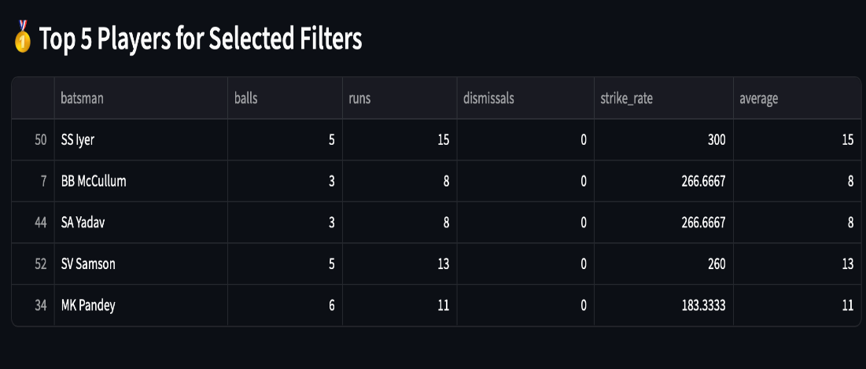
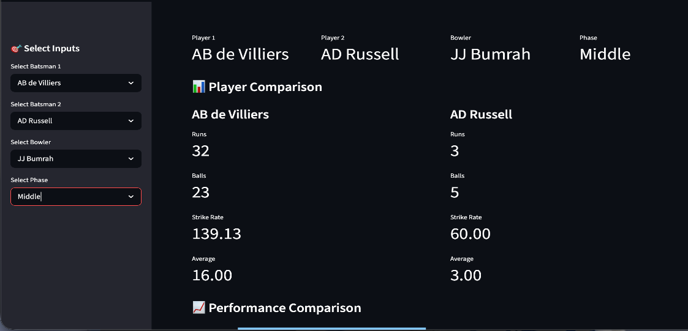
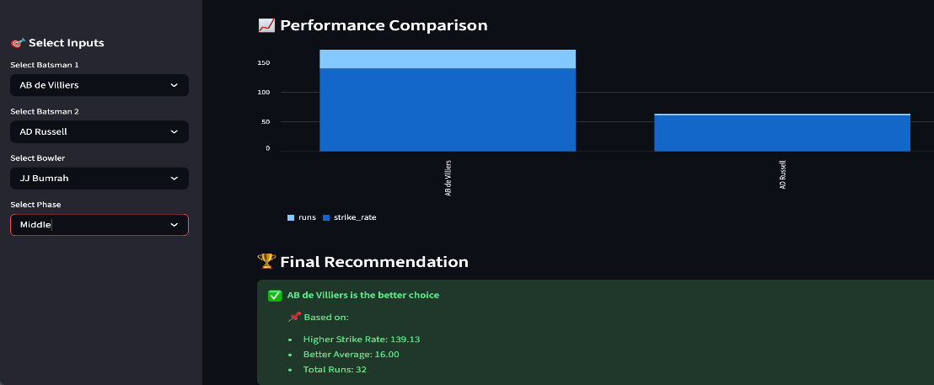
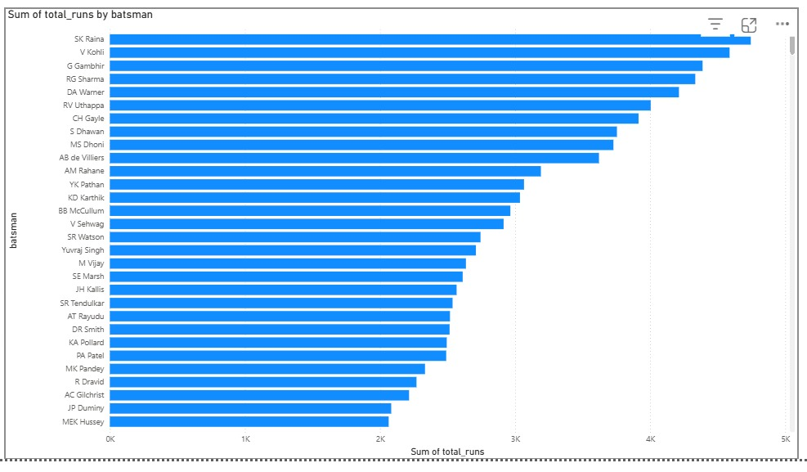

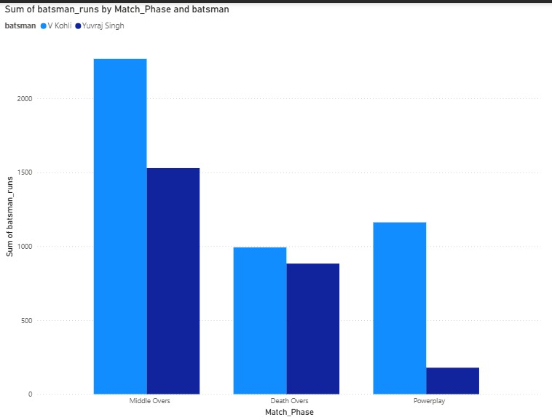

CONCLUSION

The Cricket Analytics Web Application developed in this project successfully demonstrates the effective use of data analytics techniques to analyze and interpret cricket data. By transforming raw ball-by-ball data into meaningful insights, the system provides a structured and interactive approach to evaluating player performance. The application focuses on key performance metrics such as runs, strike rate, and batting average, and enhances traditional analysis by incorporating contextual factors like match phase and bowler-specific conditions.
One of the major achievements of this project is the development of an interactive web-based interface using Streamlit. The application allows users to dynamically select players, match phases, and bowlers, and instantly view performance comparisons. This real-time interaction improves user experience and enables quick decision-making. The integration of graphical visualizations such as bar charts further enhances the clarity of results, making it easier to understand patterns and differences in player performance.
The system also introduces a recommendation feature that identifies the better-performing player based on calculated metrics. This adds a decision-support capability to the application, making it useful not only for analysis but also for practical applications such as player selection and strategy planning. Additionally, the top player ranking functionality helps in identifying consistent performers under different conditions, providing deeper insights into overall performance trends.
The experimentation and results confirm that the system is accurate, efficient, and reliable. It performs well under various scenarios and provides consistent outputs without errors. The modular structure of the code ensures that the system is easy to maintain and extend, allowing for future enhancements.
In conclusion, the project highlights the importance of data-driven decision-making in sports and demonstrates how even simple analytical techniques can produce valuable insights when applied effectively. The system provides a strong foundation for further development, such as integrating real-time data, incorporating advanced predictive models, or deploying the application on a larger platform. Overall, the Cricket Analytics Web Application serves as a practical and efficient solution for modern cricket analysis.

REFRENCES

- Apache Spark Documentation,
https://spark.apache.org/docs/latest/
- IPL Dataset (Ball-by-Ball Data), Kaggle,
https://www.kaggle.com/datasets
- Xindong Wu et al., “Data Mining with Big Data,”
IEEE Transactions on Knowledge and Data Engineering, vol. 26, no. 1, pp. 97–107, 2014.
- IBM Big Data Analytics,
https://www.ibm.com/analytics/hadoop/big-data-analytics
- Sports Analytics Overview,
https://www.ncbi.nlm.nih.gov/pmc/articles/PMC9137953/
- Introduction to Big Data in Sports,
https://www.leewayhertz.com/big-data-in-sports/
- Machine Learning for Sports Analytics,
https://www.analyticsvidhya.com/blog/sports-analytics

